

Purpose of the Program: CBI is a vocational program for students who are having a difficult time with the normal education process. The CBI program places heavy emphasis on remedial instruction, vocational orientation, and private sector work experience.

Canfield

CBI Coordinators

C

Anthony Holben

(330)533-5507 ext. 2007

[aholben@canfieldschools.net](mailto:aholben@canfieldschools.net)

Tony Ross

(330)533-5507 ext. 2203

[aross@canfieldschools.net](mailto:aross@canfieldschools.net)

Anthony Holben

CBI/CSC Coordinator

**Tony Ross**

CBI/Dean of Students



Program Content

The CBI program provides work related and remedial instruction with the CBI teacher coordinator for one period of the school day. The student is also integrated into academic classes each day, taught by teachers other than the CBI coordinator. Along with the classroom experience, the CBI student receives work experience in the private sector.

**Program Instruction**

The related instruction in this program is under the direction of the CBI coordinator. The teacher coordinator will provide career exploration instruction and job performance information.

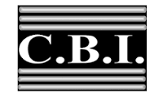

Canfield High School

Career Based Intervention

Program

(CBI)

Enrollment requirements: any student may be considered for enrollment into the CBI program. The student identification should be made through the joint efforts of the Guidance Department, classroom teachers, Administration, and CBI Coordinators

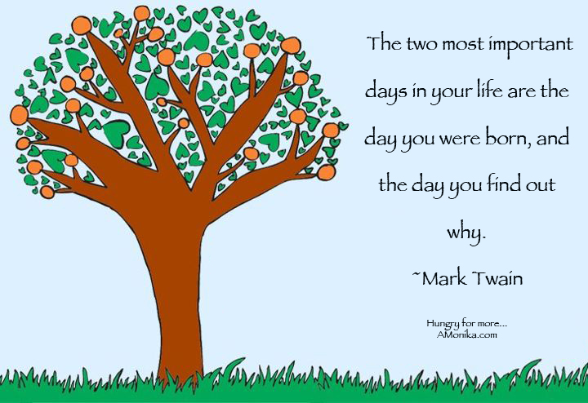

* To develop student motivation.
* To change attitude toward education.
* To develop, through work experience, the necessary attitudes and abilities to enable students to become a productive student and citizen.
* To encourage the student to continue his/her education as long as possible
* To help the student to adjust to different environments.
* To give a sense of dignity and worth to the individual.
* To develop more appreciation of the value of wages.
* To learn how to get along with fellow workers and employees.
* To learn to assume greater responsibility.
* To teach the student the rights and responsibilities of a citizen.

CBI Objectives

CBI Philosophy

Canfield High School CBI believes that each child is entitled to an opportunity to establish and attain realistic goals.

**WE BELIEVE:**

The administration should provide the students with qualified, enthusiastic, and resourceful instructors for this program.

**WE BELIEVE:**

It is the responsibility of the instructor to offer a curriculum which will provide for individual interest and abilities.

**WE BELIEVE:**

Students should be guided toward the achievement of desirable personal qualities.

**WE BELIEVE:**

Knowledge alone does not make a person, but the knowledge combined with wholesome, social, emotional, and moral responsibilities does not enable the person to become a worthwhile citizen of the community and the world.

**WE BELIEVE:**

The effective cooperation between school and community will enhance the effectiveness of the whole school process.

In the final analysis, we must not lose sight of the basic truth that the most important element in educating our youth is the personal relationship between pupil and student.